

# TECHSAKSHAM

**FINAL PROJECT REPORT**

NAME OF PROJECT

**E- COMMERCE Website based on NOTES.**

**RAYALASEEMA UNIVERSITY COLLEGE OF ENGINEERING, KURNOOL**

By

**S.K. JANI BEGUM [19RU1A0546]**

**N. VIDYAVATHI [19RU1A0537]**

**B. SHRAVYA VANI [19RU1A0504]**

**K.N. JAYALAKSHMI [19RU1424]**

# 1. INTRODUCTION

The growing significance of websites for various organizations is well known. In recognizing that we decided to develop a website for the college students which comprises of the required study material, examination papers.

**1.1 Purpose of the project:**

The purpose of the project is to design, publish and maintain a website for our college students which consists of all study material, model papers, previous year papers ....etc., accordingly to their respective branches and the pursuing years.

**1.2 Current and Proposed System:**

**1.2.1 Current System:**

As the existing website is just a static one, we need it to make it a dynamic one.

**1.2.2 Proposal System:**

Initially the college students had a feeling of maintaining the comprehensive notes for each and every subject/course they come along each and every semester throughout their Bachelors. But due to various reasons such as the Global Pandemic, and the digitalization of the classrooms both the students as well as the faculty have got used to with the digital material in the form of pdfs, documents and ppts.

**1.3 Scope of the Project:**

This SRS applies to all the official web applications that are developed to maintain the information online. This is extended to all the domains of the applications.

**1.4 Glossary**

|  |  |
| --- | --- |
| **TERM** | **DEFINITION** |
| **HTML** | Hyper Text Markup Language |
| **CSS** | Cascading Style Sheets |
| **BOOTSTRAP** | Framework of CSS |
| **JAVASCRIPT** | Globally used programming language for Web  Development |

**Table-1.1** Technologies used in building E-commerce website based on Notes

The above technologies are required to implement the requirements due to following advantages.

**Advantages:**

* Easy to navigate
* Provides all the comprehensive information about the college.
* Flash items are provided wherever necessary.
* All the nostalgic images are provided in the gallery.

# 2. REQUIREMENTS

**2.1 Software Requirements:**

* Browser: Internet Explorer or Mozilla Firefox or Opera or Chrome
* Operating System: Any Windows/MAC version

**2.2 Hardware Requirements:**

* Processor: Intel Pentium IV or above
* RAM: 512 MB or more
* HARD DISK: 40 GB or more

**2.3 Functional Requirements:**

* The system provides all the information about the study materials, model papers, previous year papers in detail**.**
* All the information about the exam preparation materials are provided in department wise
* All the necessary information is rendered with proper images and flash slides for better navigation.
* Proper information regarding the Textbooks and the Reference Books is also included.

**2.4 Non-Functional Requirements:**

* Runs on low performance systems and on any environment**.**
* Cost effective deployment (When buying out Storage Space)
* All the languages used to develop the system are Client-side scripting languages which provide dynamic system.

# 3. SYSTEM ANALYSIS

**3.1 INTRODUCTION**

System analysis is the process of gathering and interpreting facts, diagnosing problems and using the information to recommend improvements on the system. System analysis is a problem solving activity that requires intensive communication between the system users and system developers. System analysis or study is an important phase of any system development process. The system is studied to the minutest detail and analyzed. The system analyst plays the role of an interrogator and dwells deep into the working of the present system. The system is viewed as a whole and the inputs to the system are identified. The outputs from the organization are traced through the various processing that the inputs phase through in the organization. A detailed study of these processes must be made by various techniques like Interviews, Questionnaires etc. The data collected by these sources must be scrutinized to arrive to a conclusion. The conclusion is an understanding of how the system functions. This system is called the existing system. Now, the existing system is subjected to close study and the problem areas are identified. The designer now functions as a problem solver and tries to sort out the difficulties that the enterprise faces. The solutions are given as a proposal. The proposal is then weighed with the existing analytically and the best one is selected. The proposal is presented to the user for an endorsement by the user. The proposal is reviewed on user request and suitable changes are made. This loop ends as soon as the user is satisfied with the proposal.

**3.2 EXISTING SYSTEM**

The existing notes website is static which makes it less interactive. It doesn’t have a database connectivity. Moreover, students didn’t have an access to the detailed information about the courses and the syllabus through the college website and also the updated course structures according to the year of course.

**3.3 PROPOSED SYSTEM**

In order to make the site dynamic and more interactive we have tried to include the database link to our **E-commerce website based on Notes** website. In response to which a student can now not only take a view of the model papers, previous years papers, syllabus copies ….etc., but also can download them in the pdf format/ word format for his/her personal uses also. Provision has also been made to display the faces behind the website been developed along with the links to their social media profiles (most probably Instagram).

**3.4 ARCHITECTURAL MODEL**

We have developed our project by keeping in view the **Three-Tier Architecture** by the use of multiple languages in one single development Tech-Stack.

**3.5 SOFTWARE REQUIREMENTS**

|  |  |
| --- | --- |
| OPERATING SYSTEM | Windows XP, 7, 8, 10, 11. |
| BROWSER | Internet Explorer or any HTTP Browser. |
| WEB SERVER | IIS |
| CLIENT-SIDE SCRIPTING | JavaScript |
| CONNECTION | HTTP, SMTP, POP3, WAP. |

**Table-3.1** Software Requirements

**3.6 HARDWARE REQUIREMENTS**

PROCESSOR: PENTIUM IV

CLOCK SPEED: 2 GHZ

SYSTEM BUS: 32 BIT

RAM: 128 MB

HDD: 40 GB

# MONITOR: SVGA COLOR

KEYBOARD: 108 KEYS

MODEM: 56 KBPS

MOUSE: PS/2

FDD: 1.44 MB

**SYSTEM DESIGN**

System design is the solution to the creation of a new system. This phase is composed of several systems. This phase focuses on the detailed implementation of the feasible system.

It emphasis on translating design specifications to performance specification. System design has two phases of development, Logical and Physical design.

During Logical design phase the analyst describes inputs(sources), outputs(destination), databases(data sources) and procedures(data flows) all in a format that meets the uses requirements. The analyst also specifies the user needs and at a level that virtually determines the information flow into and out of the system and data resources. Here the logical design is done through data flow diagrams and database design. The Physical design is followed by physical design or coding. Physical design produces the working system by defining the design specification, which tells the programmer exactly what the candidate system must do. The programmers write the necessary programs that accept input from the user, perform necessary processing on the accepted data through call and produce the required report on a hardcopy or display it on the screen.

## 4. TESTING

**4.1 SYSTEM TESTING**

Testing is a set activity that can be planned and conducted systematically. Testing begins at the module level and work towards the integration of entire Computers based system. Nothing is complete without testing, as it is vital success of the system.

• **Testing objectives:**

There are several rules that can serve as testing objective. They are :

* 1. Testing is a process of executing a program with the intent of finding an error
  2. A good testcase is one that has high probability of finding an undiscovered error
  3. A successful test is one that uncovers and undiscovered error.

If testing is conducted successfully according to the objectives as stated above, it would uncover errors in the software. Also, testing demonstrates that software functions appear to the working according to the specifications, that performance requirements appear to have been met.

There are three ways to test a program :

* + 1. For Correctness
    2. For Implementation Efficiency
    3. For Computational Complexity

Tests for correctness are supposed to verify that a program does exactly what it was designed to do. This is much more difficult than it may first appear, especially for large programs. Tests for implementation efficiency attempt to find ways to make a correct program faster or use less storage. It is a code-refining process, which re-examines the implementation phase of algorithm development.

Tests for computational complexity amount to an experimental analysis of the complexity of an algorithm or an Experimental comparison of two or more algorithms, which solve the same problem.

**Testing Correctness:**

The following ideas should be a part of any testing plan :

* 1. Preventive Measures
  2. Spot Checks
  3. Testing all parts of program
  4. Test Data
  5. Looking for trouble
  6. Time for Testing
  7. Re-Testing

The data is entered in all forms separately and whenever an error occurred, it is corrected immediately. A quality team deputed by the management verified all the necessary documents and tested the Software while entering data at all levels. The entire testing process can be divided into 3 phases :

* + 1. **Unit Testing**
    2. **Integrated Testing**
    3. **Final/System Testing**

**4.2 UNIT TESTING**

As this system was partially GUI based WINDOWS application, the following were tested in this phase

* + 1. Tab Order
    2. Reverse Tab Order
    3. Field Length
    4. Front-end Validations

In our system, Unit Testing has been successfully handled. The test data was given to each and every module in all respects and got the desired output. Each module has been Tested, found working properly.

**4.3 INTEGRATION TESTING**

Test data should be prepared carefully since the data only determines the efficiency and accuracy of the system. Artificial data are prepared solely for testing. Every program validates the input data.

**VALIDATION TESTING**

In this, all the Code Modules were combined and given the test data. The combined module works successfully without any side effect on other programs. Everything was found fine working.

**4.4 OUTPUT TESTING**

This is the final step in testing. In this the entire system was tested as the whole with all forms, codes, modules and class modules. This form of testing is popularly known as Black Box Testing or System Testing.

Black Box testing methods focus on the functional requirements of the software. That is, Black Box testing enables the software engineer to derive sets of input conditions that will fully exercise all functional requirements for a program. Black Box testing attempts to find errors in following categories :

* 1. Incorrect or Missing Functions
  2. Interface Errors
  3. Errors in Data Structures or External Database access
  4. Performance Errors
  5. Initialization Errors and
  6. Termination Errors

## 5. ER DIAGRAM

Entity Relationship Diagrams are used in Software Engineering during the planning stages of the software project. They help to identify different system elements and their relationships with each other. It is often used as the basis for data flow diagrams or DFD’s as they are commonly known.

In other words, ER diagrams help to explain the logical structure of databases. ER diagrams are created based on three basic concepts: entities, attributes and relationships.

ER Diagrams contain different symbols that use rectangles to represent entities, ovals to define attributes and diamond shapes to represent relationships.

At first look, an ER diagram looks very similar to the flowchart. However, ER Diagram includes many specialized symbols, and its meanings make this model unique. The purpose of ER Diagram is to represent the entity framework infrastructure.

**ER Diagrams Symbols & Notations**

**Entity Relationship Diagram Symbols & Notations** mainly contains three basic symbols which are rectangle, oval and diamond to represent relationships between elements, entities and attributes. There are some sub-elements which are based on main elements in ERD Diagram. ER Diagram is a visual representation of data that describes how data is related to each other using different ERD Symbols and Notations.

**Following are the main components and its symbols in ER Diagrams:**

* **Rectangles:** This Entity Relationship Diagram symbol represents entity types
* **Ellipses :** Symbol represent attributes
* **Diamonds:** This symbol represents relationship types
* **Lines:** It links attributes to entity types and entity types with other relationship types
* **Primary key:** attributes are underlined
* **Double Ellipses:** Represent multi-valued attributes

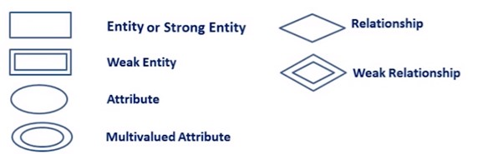

**Fig 5.1** ER Diagram Symbols

**Components of the ER Diagram**

This model is based on three basic concepts:

* Entities
* Attributes
* Relationships

**Entity:**

A definable thing—such as a person, object, concept or event—that can have data stored about it. Think of entities as nouns.

Examples: a customer, student, car or product. Typically shown as a rectangle.

**Attribute(s):**

Attributes are the **properties which define the entity type.**

For example, Roll_No, Name, DOB, Age, Address, Mobile_No are the attributes which defines entity type Student. In ER diagram, attribute is represented by an oval.

**Relationships:**

Relationships, which are represented by diamond shapes, show how two entities share information in the database.

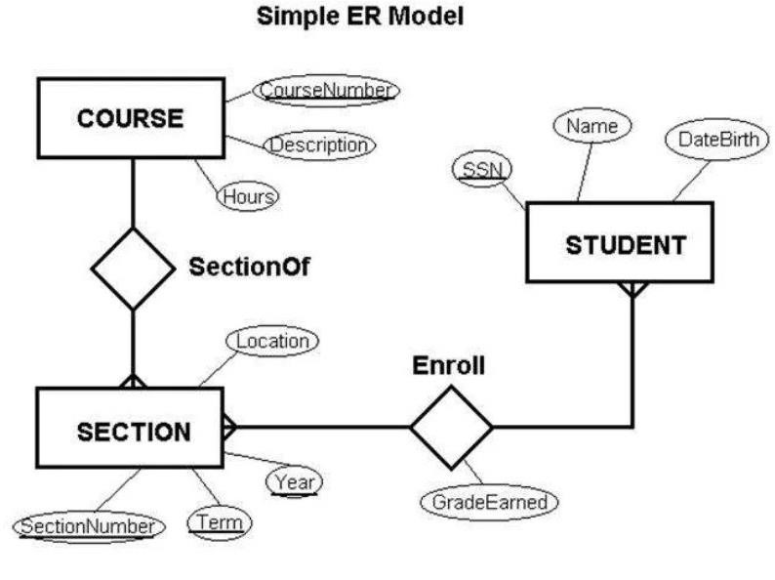

**Fig 5.2** Simple ER Model

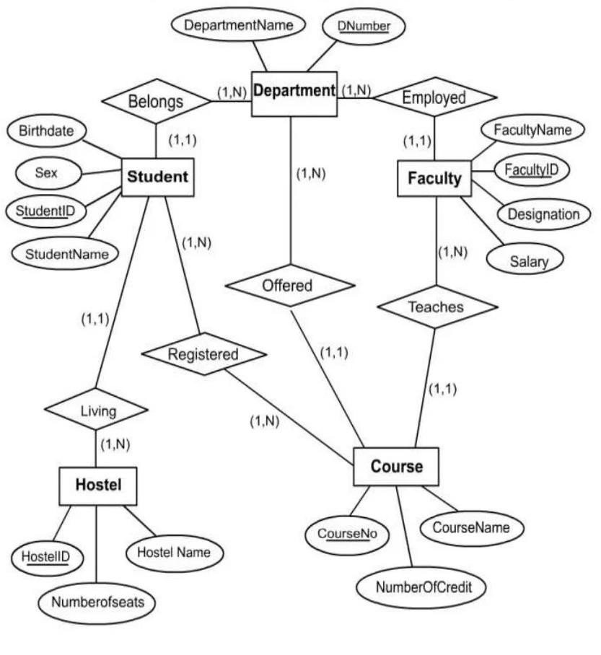

**Fig 5.3** ER Model of the Website Designed

**6. DATA FLOW DIAGRAMS**

A Data Flow Diagram (DFD) maps out the flow of information for any process or system. It uses defined symbols like rectangles, circles and arrows, plus short text labels, to show data inputs, outputs, storage points and the routes between each destination. Data flowcharts can range from simple, even hand-drawn process overviews, to in-depth, multi-level DFDs that dig progressively deeper into how the data is handled. They can be used to analyze an existing system or model a new one. Like all the best diagrams and charts, a DFD can often visually “say” things that would be hard to explain in words, and they work for both technical and nontechnical audiences, from developer to CEO. That’s why DFDs remain so popular after all these years. While they work well for data flow software and systems, they are less applicable nowadays to visualizing interactive, real-time or database-oriented software or systems.

Data Flow Diagram (DFD) is a traditional visual representation of the information flows within a system. A neat and clear DFD can depict the right amount of the system requirement graphically. It can be manual, automated, or a combination of both.

It shows how data enters and leaves the system, what changes the information, and where data is stored.

The objective of a DFD is to show the scope and boundaries of a system as a whole. It may be used as a communication tool between a system analyst and any person who plays a part in the order that acts as a starting point for redesigning a system. The DFD is also called as a data flow graph or bubble chart.

**The following observations about DFDs are essential:**

1. All names should be unique. This makes it easier to refer to elements in the DFD.
2. Remember that DFD is not a flow chart. Arrows is a flow chart that represents the order of events; arrows in DFD represents flowing data. A DFD does not involve any order of events.
3. Suppress logical decisions. If we ever have the urge to draw a diamond-shaped box in a DFD, suppress that urge! A diamond-shaped box is used in flow charts to represents decision points with multiple exists paths of which the only one is taken. This implies an ordering of events, which makes no sense in a DFD.
4. Do not become bogged down with details. Defer error conditions and error handling until the end of the analysis.

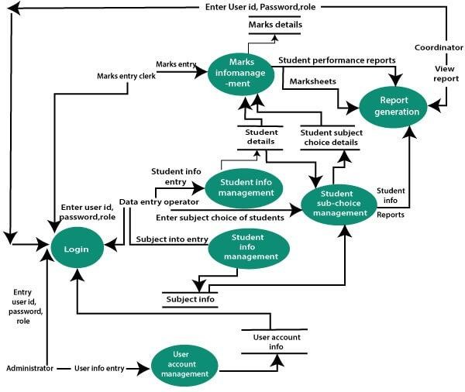

**Fig 6.1** Data Flow Diagram for the Website Developed

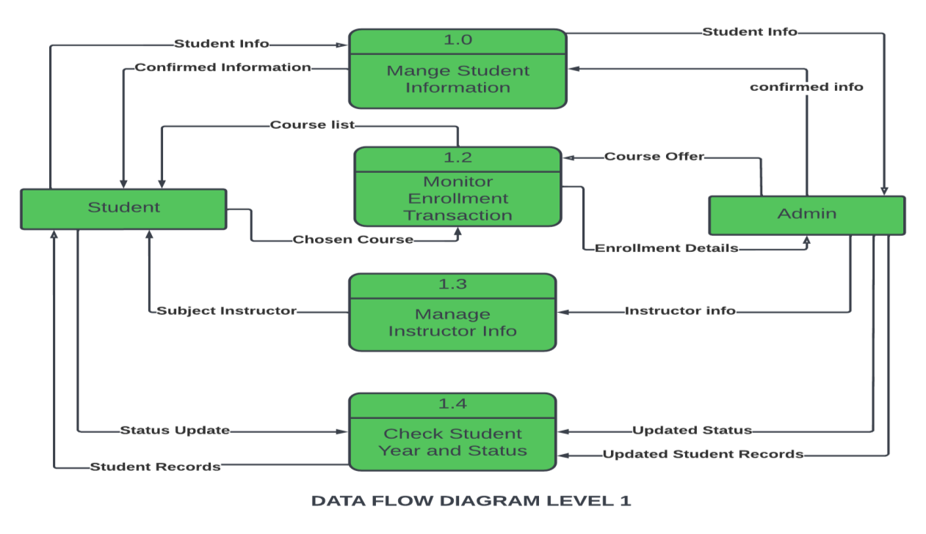

**Fig 6.2 DFD** (Level 1) for the Website Developed

## 7. UML DIAGRAMS

**UML Diagrams :**

It is the general-purpose modeling language used to visualize the system. It is a graphical language that is standard to the software industry for specifying, visualizing, constructing, and documenting the artifacts of the software systems, as well as for business modeling.

**Types of UML:**

1. Structural UML diagrams

* Class diagram
* Package diagram
* Object diagram
* Component diagram
* Composite structure diagram
* Deployment diagram

1. Behavioral UML diagrams
   * Activity diagram
   * Sequence diagram
   * Use case diagram
   * State diagram
   * Communication diagram
   * Interaction overview diagram
   * Timing diagram

**Use Case Diagram:**

The Use Case Diagram is a UML Diagrams where the each use-case specifies the behaviour expected from software from the perspective of end-user and relation as well as provides brief overview for different components concerning interaction between use-case, actors and systems .

The Use-Case Diagram is used to prepare, present and understand functional requirements of the system. Use-Case Diagram specifies exact context of the software being developed. It does not specifies order in which actions must be performed. Each use-case represents function of system which is either process-automated or manual.

**UML DIAGRAM:**

USE CASE DIAGRAM

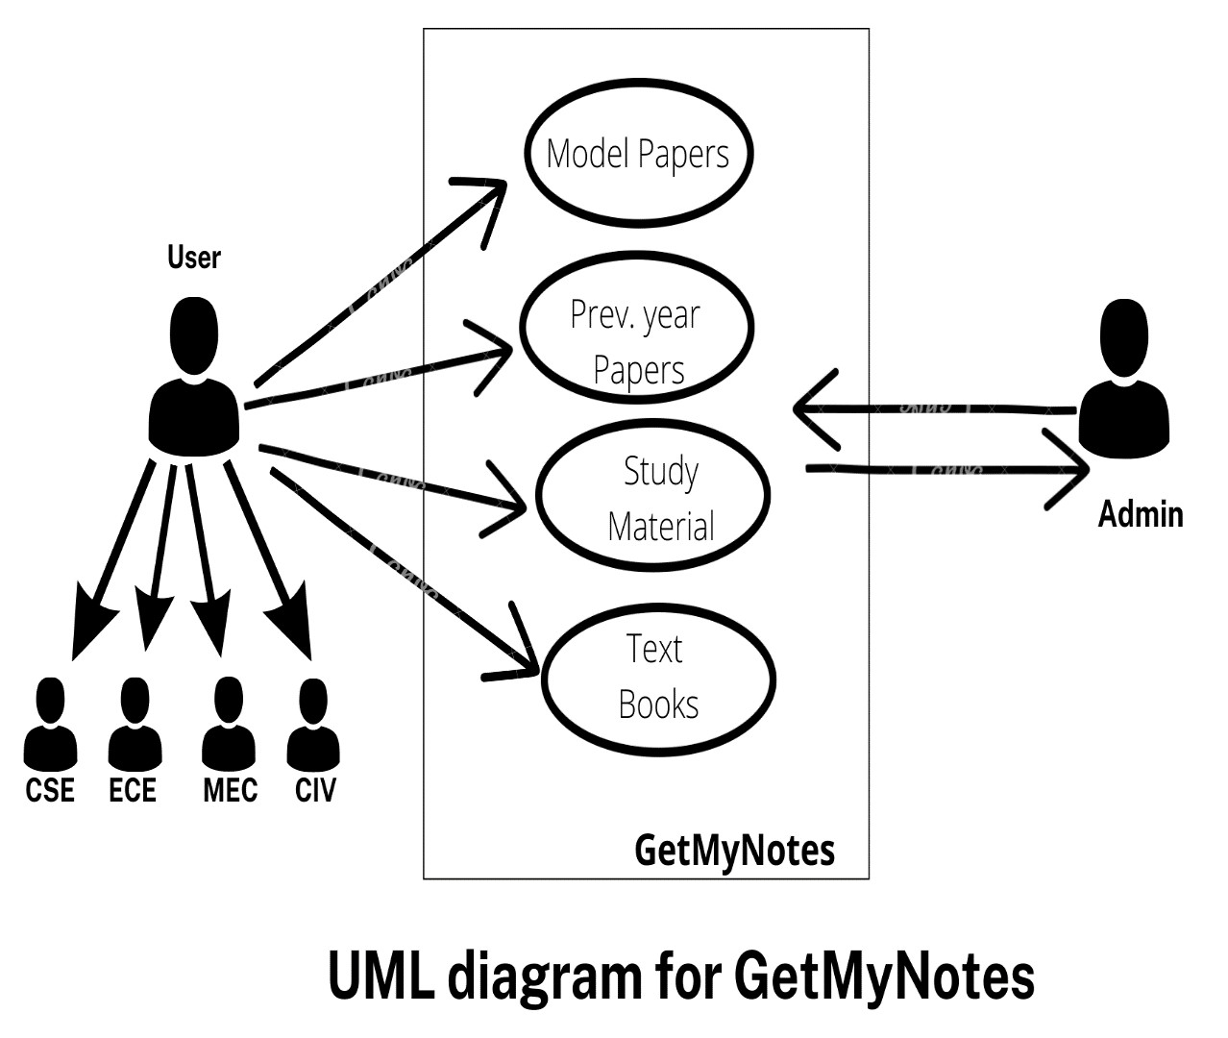

**Fig 7.1** Use Case Diagram of Website

**8. RESULTS**

This project is to provide the students the better service by providing articles, notes, textbooks, previous year question papers, reference textbooks, syllabus copies, videos regarding various branches to prepare for exams. It also helps the faculty within our college to identify the prospective students and pay attention to and improve their knowledge by sharing our website. A number of companies place importance on the academic performance of the candidate and place requirements for minimum marks. Students can also be able to check their results. Any student can utilize our website and increase their knowledge which has direct impact on their marks and CGPA.

Technology plays a crucial role in today’s education system. Mobile learning has become widespread, and higher educational institutions have started adopting mobile technology to cope with the needs of students. It allows students to access learning content from various locations with no time. Our goal is to design and develop an application website that assists students to enhance individual pass percentage by referring the well-organized content. The users will able to experience good web-based mobile learning environments.

Our website i.e **“**E-commerce website based on Notes**”** can be viewed in two ways or on two kind of devices.

They are :

* **Desktop View**
* **Smart-Phone View**

**DESKTOP VIEW :**

* Designed for large screens with precise mouse clicking.
* Most desktop monitors measure 19 inches to 24 inches diagonally.
* Sponsored links and large banner ads more common.
* Denser text with more leeway for graphics.

Page Controls:

* More precise cursor-based links and button.

**MOBILE VIEW:**

* Designed for smaller screens and imprecise finger tapping.
* Smartphone and tablet display measure 4 to 10 inches diagonally.
* Collapsible or expandable menu widgets typically replace sidebars and bulky header menus.
* Full-width graphics with judicial use of space between text.

Page Controls:

* Large tapping areas or hotspots for more accurate navigation.
* Different URL: adds the letter "m." Often an option to view the desktop version of a site.
* Log-in credentials often have dedicated space, sometimes with fingerprint accessibility.

**SOME CAPTURES OF THE DESKTOP VIEW:**

**Fig 8.1.1:** Website Introduction

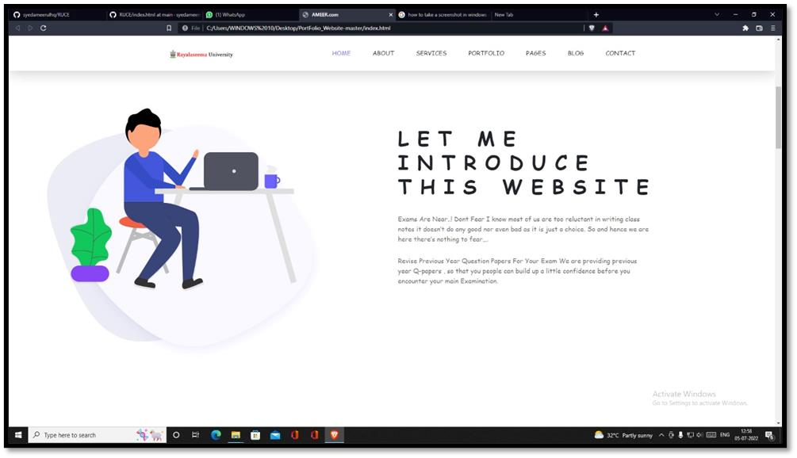

**Fig-8.1.2:** Landing Page

**Fig 8.**

**1.**

**3**

**:**

Services Offered

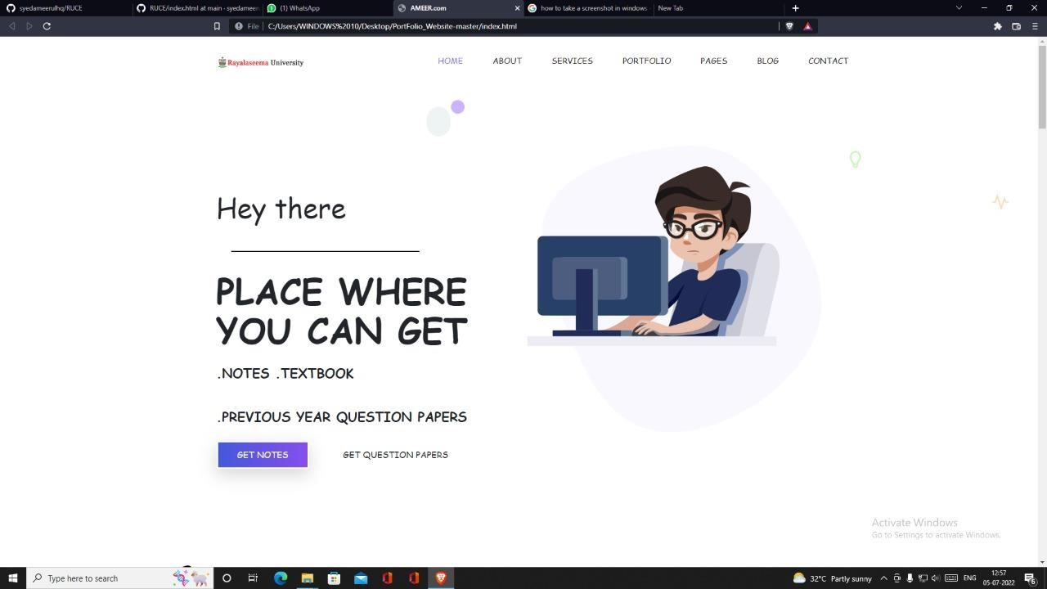

**Fig-8.1.4:** Subjects and Branches

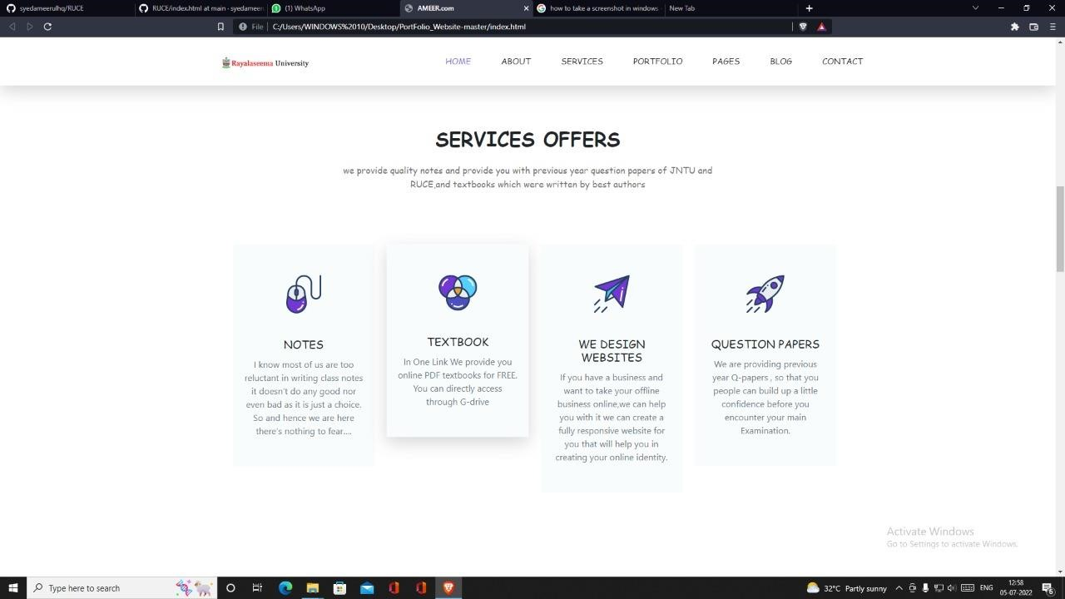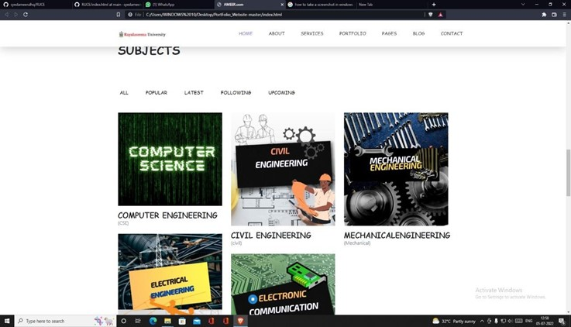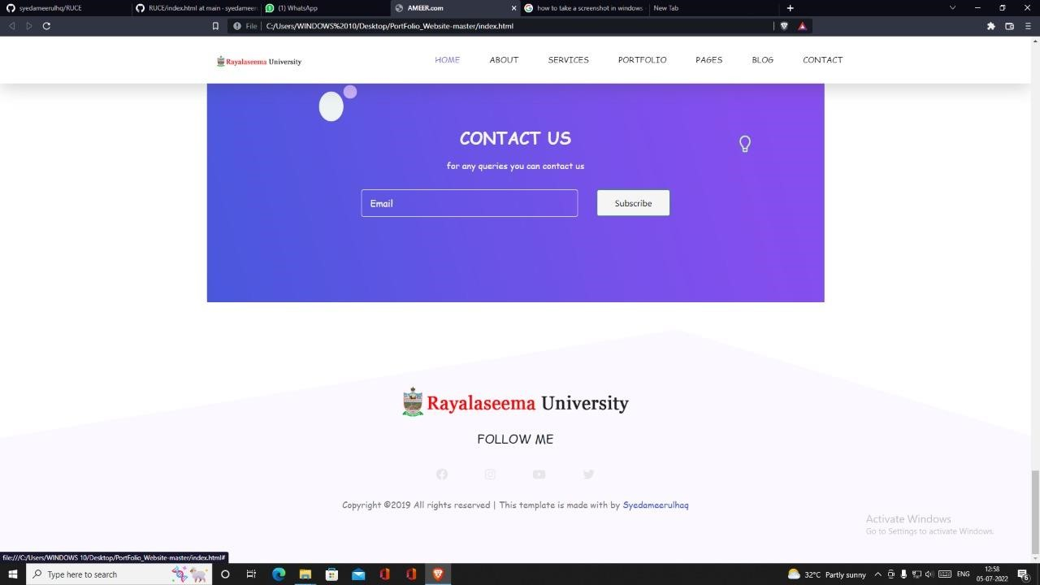

**SOME CAPTURES OF THE MOBILE VIEW :**

**Fig 8.2.1:** Website Introduction

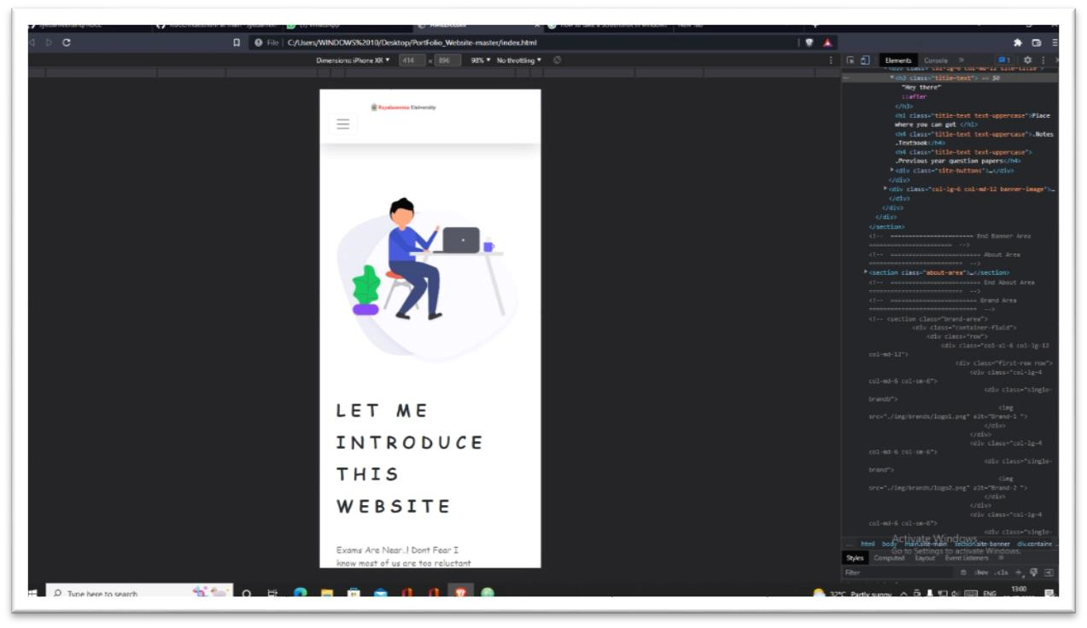

**Fig 8.2.2:** Landing Page-1

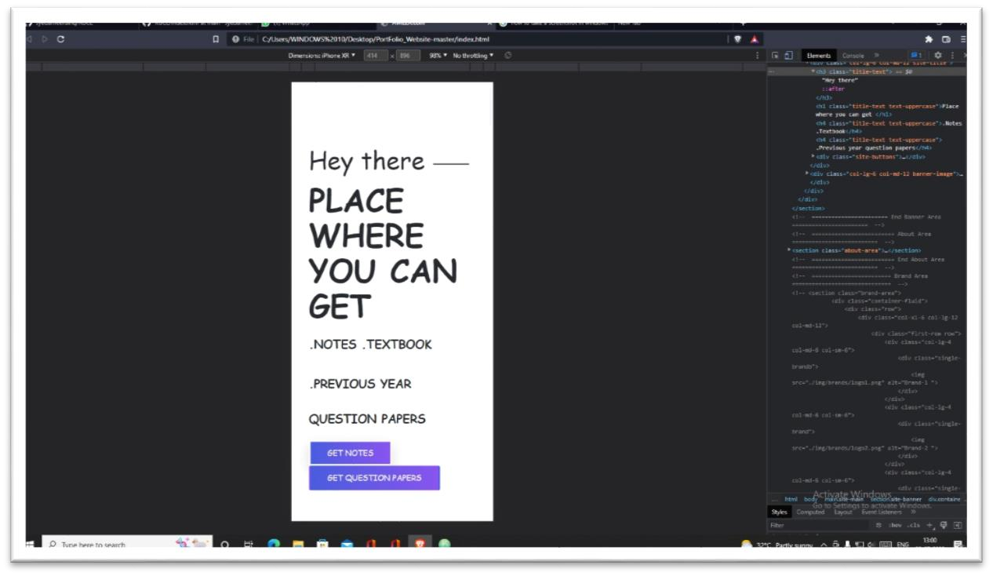

**Fig 8.2.3:** Landing Page-2

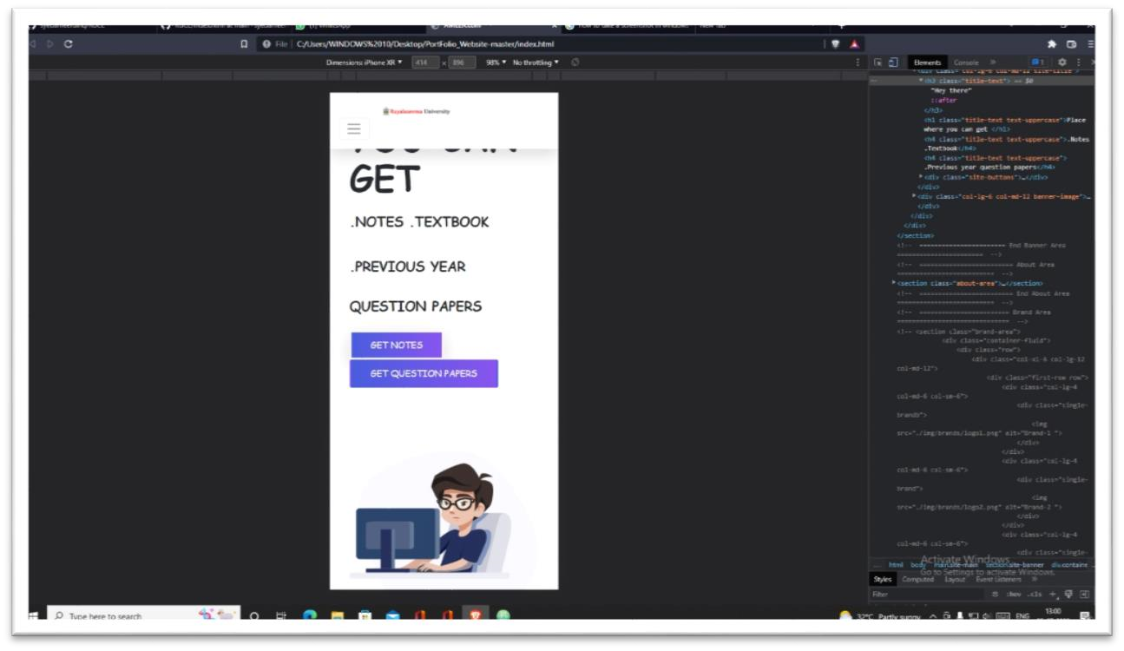

**Fig 8.2.4:**Services Offered

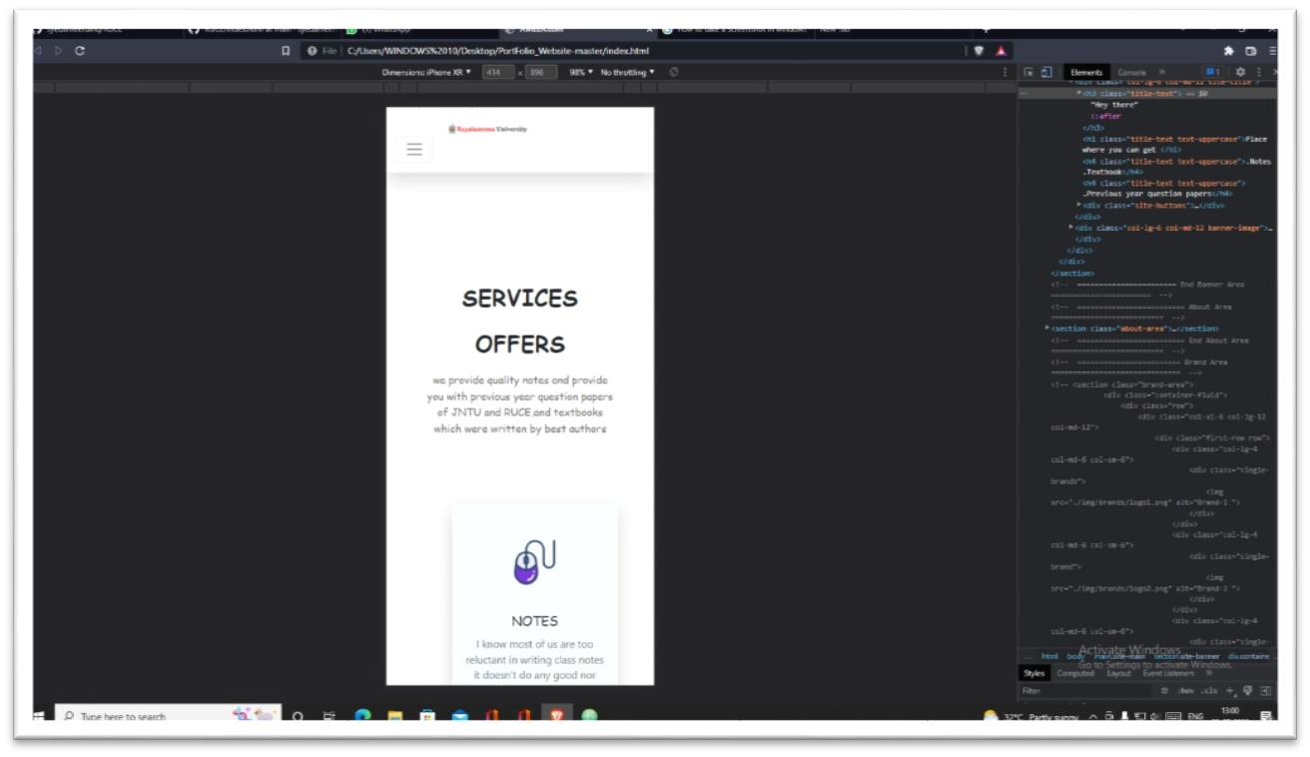

**Fig 8.2.5:** Textbook Section

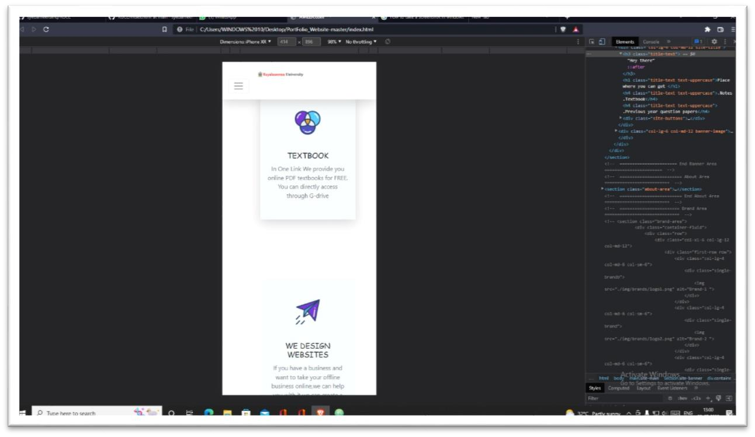

**Fig 8.2.6:** Website Design Section

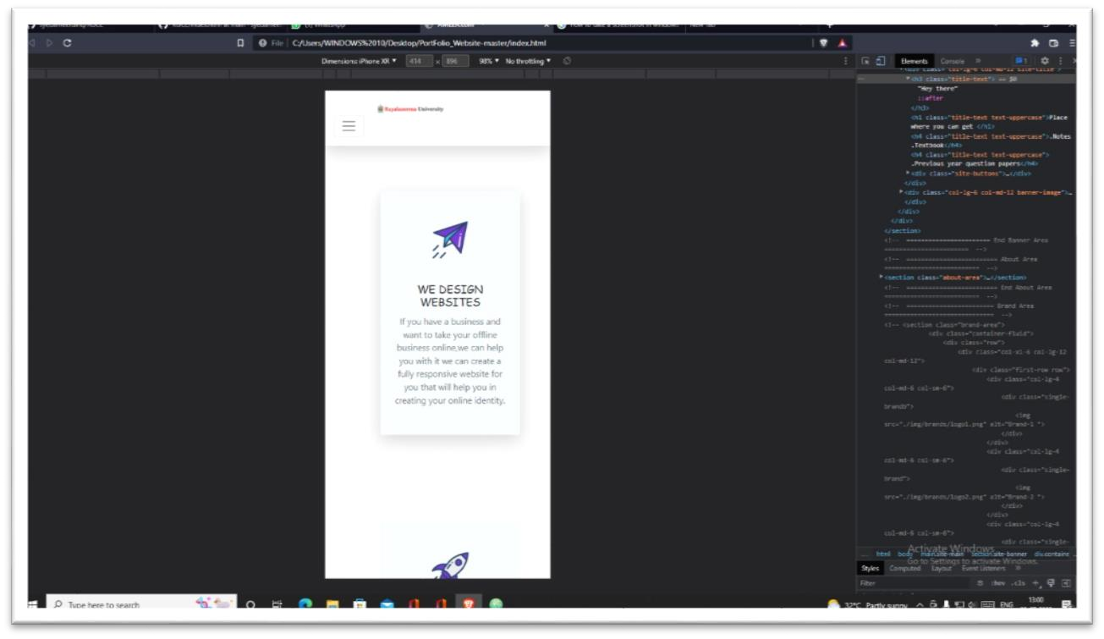

**Fig 8.2.7:** Question Paper Section

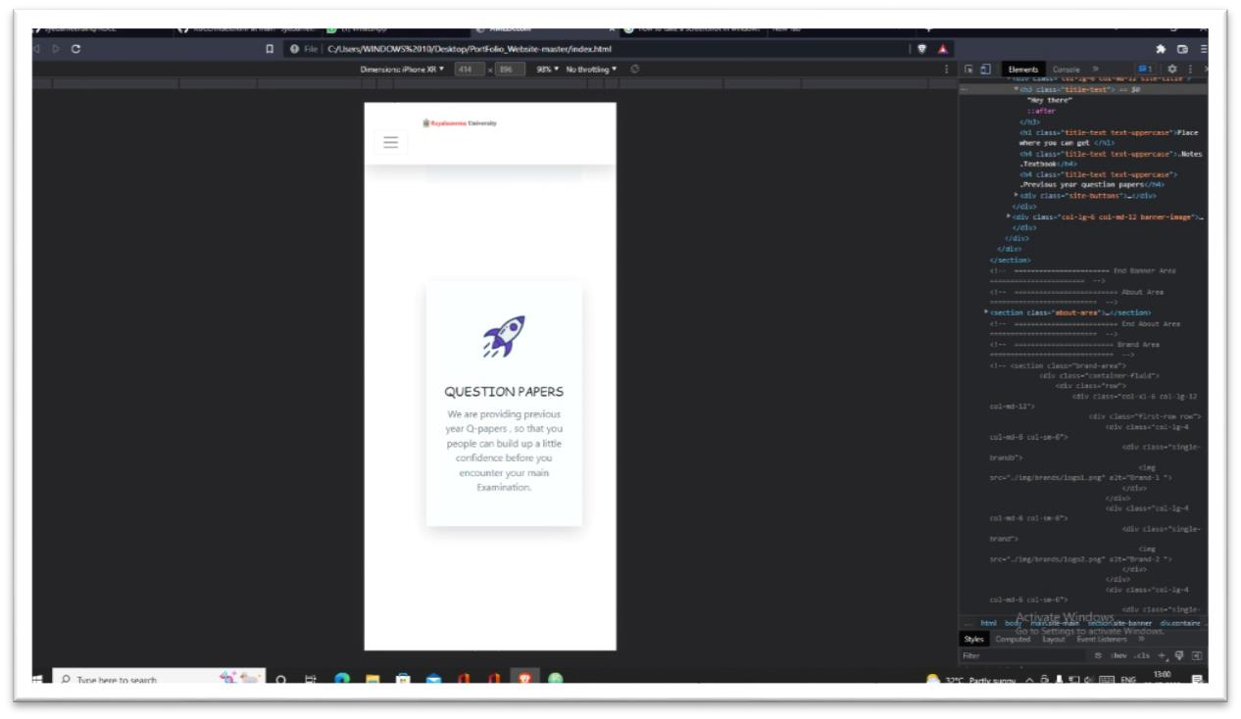

**Fig 8.2.8:** Subjects and Branches

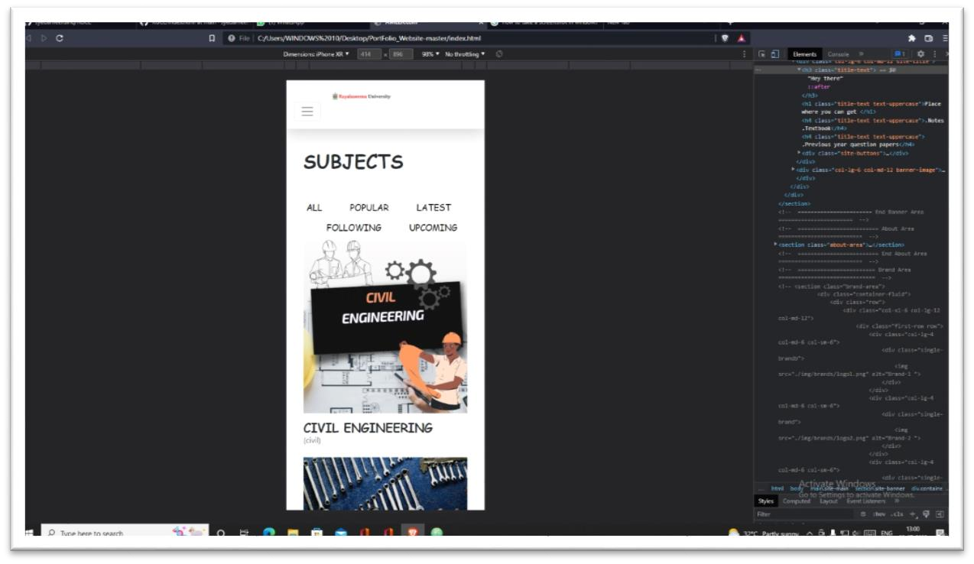

**Fig 8.2.11:** Contact us

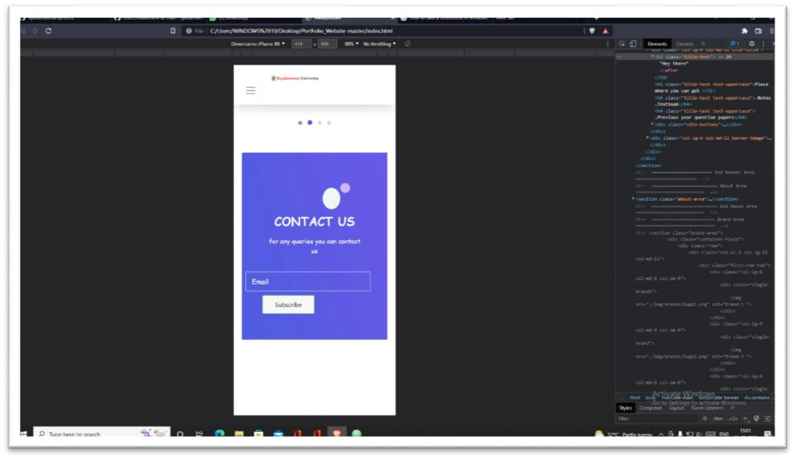

**Fig 8.2.12:** Connect with us

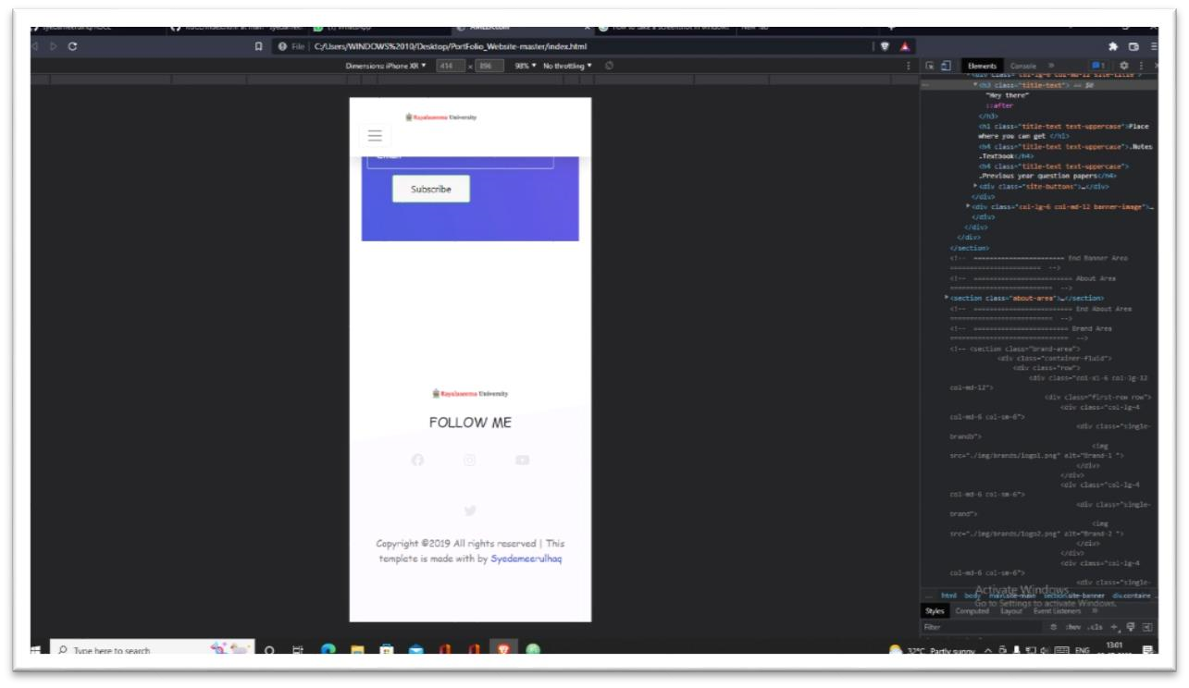

## 9. CONCLUSION

By completing this Capstone-project, we achieved the main aim of this project to provide the students the better service by providing articles, notes, textbooks, previous year question papers, reference textbooks, syllabus copies, videos regarding various branches to prepare for exams. We are also helping the faculty within our college to identify the prospective students and pay attention to and improve their knowledge by sharing our website.

A number of companies place importance on the academic performance of the candidate and place requirements for minimum marks. Students are also able to check their results. Students are able to utilize our website and increase their knowledge which has direct impact on their marks and CGPA.

Technology plays a crucial role in today’s education system. Mobile learning has become widespread, and higher educational institutions have started adopting mobile technology to cope with the needs of students. It allows students to access learning content from various locations with no time.

We have achived our goal is to design and develop an application website that assists students to enhance individual pass percentage by referring the well-organized content. The users will able to experience good web-based mobile learning environments.

## 10. BIBLIOGRAPHY

REFERENCES:

* <https://www.oreilly.com/library/view/javascript-the-definitive/9781491952016/>
* [https://www.wiley.com/enus/Web+Design+with+HTML%2C+CSS%2C+JavaScript+and+jQuery+Set-p9781118907443](https://www.wiley.com/en-us/Web+Design+with+HTML%2C+CSS%2C+JavaScript+and+jQuery+Set-p-9781118907443)
* [https://www.wiley.com/enus/HTML+and+CSS%3A+Design+and+Build+Websites-p-9781118008188](https://www.wiley.com/en-us/HTML+and+CSS%3A+Design+and+Build+Websites-p-9781118008188)  <https://www.oreilly.com/library/view/learning-web-design/9781491960196/>
* [https://www.udemy.com/course/the-complete-web-developmentbootcamp/?src=sac&kw=the+complete+we](https://www.udemy.com/course/the-complete-web-development-bootcamp/?src=sac&kw=the+complete+we)
* <https://www.oreilly.com/library/view/css-mastery-advanced/9781590596142/>
* [https://www.pearson.com/us/higher-education/program/Aquino-Front-End-Web-](https://www.pearson.com/us/higher-education/program/Aquino-Front-End-Web-Development-The-Big-Nerd-Ranch-Guide/PGM333232.html)

[Development-The-Big-Nerd-Ranch-Guide/PGM333232.html](https://www.pearson.com/us/higher-education/program/Aquino-Front-End-Web-Development-The-Big-Nerd-Ranch-Guide/PGM333232.html)

* <https://www.w3schools.com/html/default.asp>
* <https://www.w3schools.com/css/default.asp>
* <https://www.w3schools.com/js/default.asp>
* <https://www.w3schools.com/bootstrap/bootstrap_ver.asp>
* <https://www.w3schools.com/bootstrap4/default.asp>
* <https://www.w3schools.com/js/js_htmldom.asp>
* <https://nptel.ac.in/courses/106105224>
* <https://nptel.ac.in/courses/106105182>
* <https://onlinecourses.swayam2.ac.in/nou22_cs11/preview>